Experiment No. 14
Implementation of Alpha-Beta Pruning Algorithm for Gaming
Question: Write a Python program to implement the Alpha-Beta Pruning algorithm for a Tic-Tac-Toe game.
Aim: To implement the Alpha-Beta Pruning algorithm to improve the efficiency of the Minimax algorithm by eliminating unnecessary branches in the game tree.
Algorithm:
- Start the program.
- Initialize the game board.
- Set alpha to negative infinity and beta to positive infinity.
- Check whether the current game state is a win, loss, or draw.
- Assign a score to the terminal state.
- Generate all possible legal moves.
- For the maximizing player, update alpha with the maximum score.
- For the minimizing player, update beta with the minimum score.
- If alpha is greater than or equal to beta, prune the remaining branches.
- Continue evaluating the necessary moves.
- Select the best move for the computer.
- Repeat until the game ends.
- Display the result and stop the program.
Code:
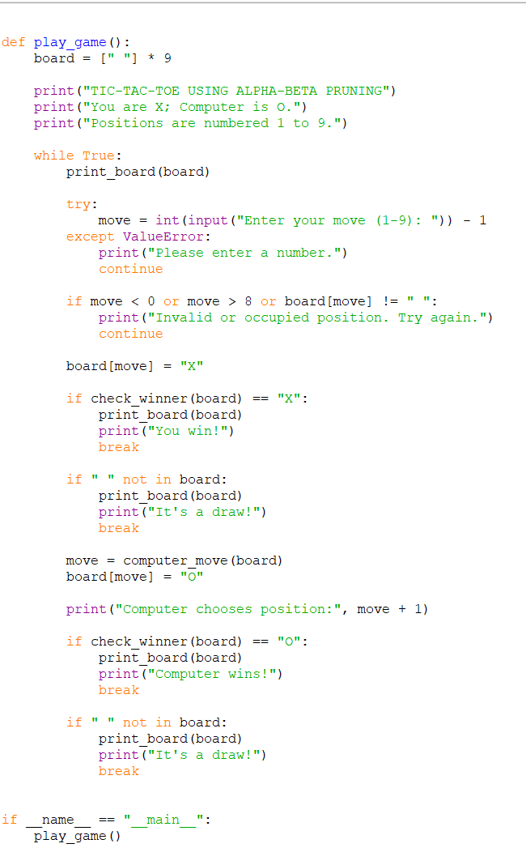
Output:
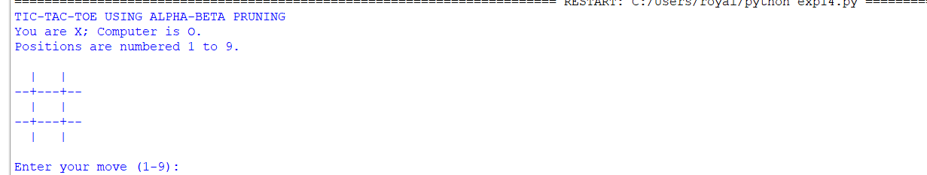

Result: The Alpha-Beta Pruning algorithm was successfully implemented in Python to reduce unnecessary game-tree exploration while maintaining optimal decision-making.

